CS558 Client Server Trading System using Socket Programming

### Allam Eswara Bhargav— 214101004, Alvin Banerjee— 214101005, and Amit Pawar — 214101006

#### M.Tech CSE IIT-G

# Introduction

There will be a set of traders who will trade with each other in the automated system. There will be a Server which will register requests from traders for buying and selling quantities of Items. The Server will also match the buy with the sell requests from different traders based on certain price rules. Traders will log on to the trading system through the trading client with Trader ID and password is stored in a text file. They will have the option to view the currently available items for buy or sell, their quantities and their prices. They will also send requests for buying and selling items and specify the quantity and price. Traders will also have the option to view their matched trades at any time.

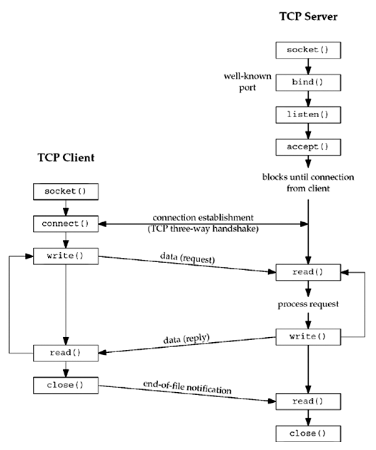

# 2. Data Structures

## 2.1 Trader

##### 2.1.1 Properties

* + - * name – Represents the name of trader
      * password – Represents password of trader
      * username – Represents unique name assigned to trader
      * all trades – Stores all trades performed by trader

## 

## 2.2 Order

##### 2.2.1 Properties

* + - * trader – Represents the trader that added the order to system
      * match – Represents the trader that fulfilled the order
      * itemId – Represents the unique item id of the order in system
      * quantity – Represents the order quantity
      * price – Represents the order price item

**2.3 Items**

##### 2.3.1 Properties

* + - * itemId – represents the unique id of item
      * price – represents the current (last traded) price of item
      * buy book – represents the order list on buy side in descending order
      * sell book – represents the order list on sell side in ascending order

**2.4 Functions**

* + - * get_trade_status – The trader can view his/her matched trades. This will provide the trader with the details of what orders were matched, their quantities, prices and counterparty code.
      * view_order_status – The Trader can view the position of buy and sell orders in the system. This will display the current best sell (least price) and the best buy (max price) for each item and their quantities.
      * insert_into_buy_queue – function to insert any buy request in the queue along with item no,quantity, price and trader_id.
      * insert_into_sell_queue – function to insert any sellrequest in the queue along with item no,quantity, price and trader_id.
      * update_file – function to update the text file for a specific trader after performing either buy request or sell request.
      * initialize – function to initialize all item_number files and insert any buy request or sell request into that item_number file.
      * handle_buy_request – function to handle on a buy Request at price P and quantity Q of an item I.
      * handle_sell_request – function to handle on a sell Request at price P and quantity Q of an item I.
      * error – function to print error message
      * verifyLogin – function to verify login details
      * getLoginDetails – function to get login details from a text file called pass.txt
      * RequestSender – function to request the sender to enter the item code , total quantity to buy, price per item
      * StatusViewer – function to check the status of buy and sell orders
      * LoginUtil – function for checking whether login credentials is correct or not from pass.txt file

# 3. Modules

## 3.1 Client-Server architecture and flow

When the server starts, a designated port is assigned to the server, on which server accepts new requests from clients. When the client starts, the IP address and port number of the server is given to it. Client sends request to create connection on that IP address on a given port. Once the server receives the request from the client, it accepts the connection and assigns that client a new port, with which the client will communicate for further tasks.

##### 3.1.1 Login

A server accepts trader logins using different clients. A trader can login using at most one client at a time. Multiple traders are allowed in one client system. So, this makes it one to many

##### 3.1.2 Registration

A trader can register using clients. Trader provides name, username and password while registering from the client. Server stores the credentials in a file and allows the trader to perform trades in available Items. Currently at most five registrations are allowed.

##### 3.1.3 Buy

This function takes the details of an order i.e. item name, price, quantity and adds a buy order in the queue.

##### 3.1.4 Sell

This function takes the details of an order i.e. item name, price, quantity and adds a sell order in the queue.

**3.1.5 Order Status**

This function shows all the positions of buy and sell orders in the system i.e. the current best sell price and best buy price for each item.

##### 3.1.6 Trade Status

This function shows the matched trades of a particular trader.

**4. Output**

**4.1 Server and Client**

**4.1.1** Here Server is listening on designated port number 5522.

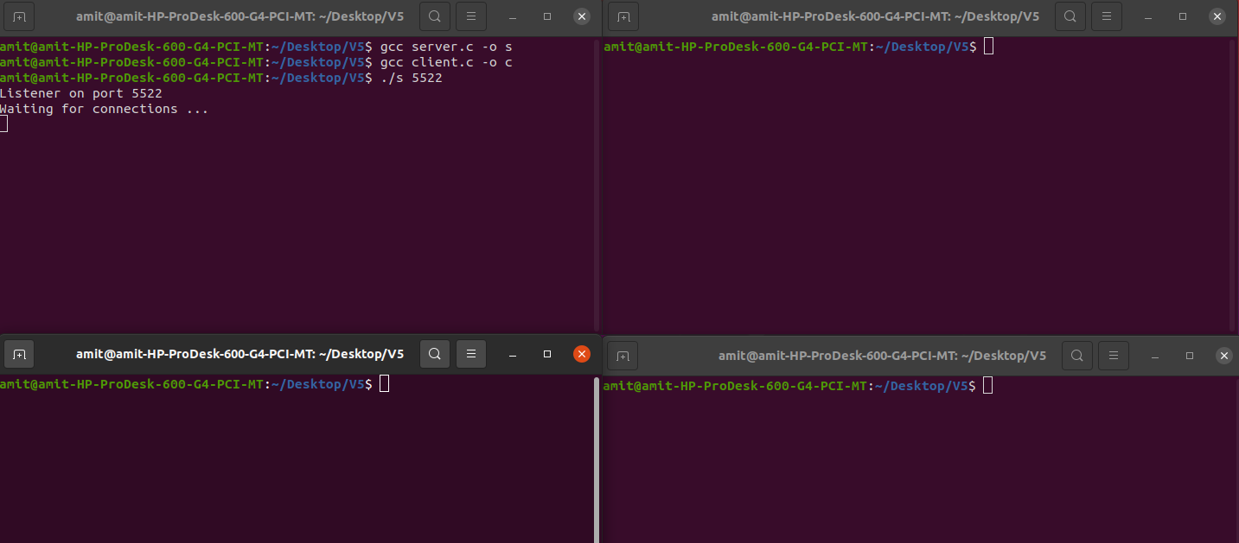

**4.1.2**  Here Server is listening on port number 5522 and when the first client starts, the IP address 172.16.115.208 and port number 5522 of the server is given to it. First Client sends request to create connection on that IP address on a given port.Once the server receives the request from the client, it accepts the connection and assigns that client a new port number 63737, with which the client will communicate for further tasks.

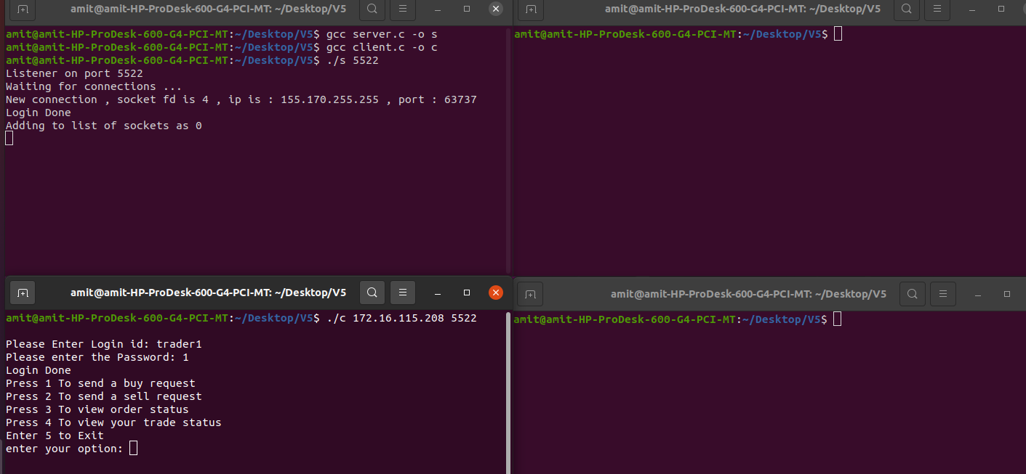

**4.1.3** Here Server is listening on port number 5522 and when the second client starts, the IP address 172.16.115.208 and port number 5522 of the server is given to it. Second Client sends request to create connection on that IP address on a given port.Once the server receives the request from the client, it accepts the connection and assigns that client a new port number 42746, with which the client will communicate for further tasks.

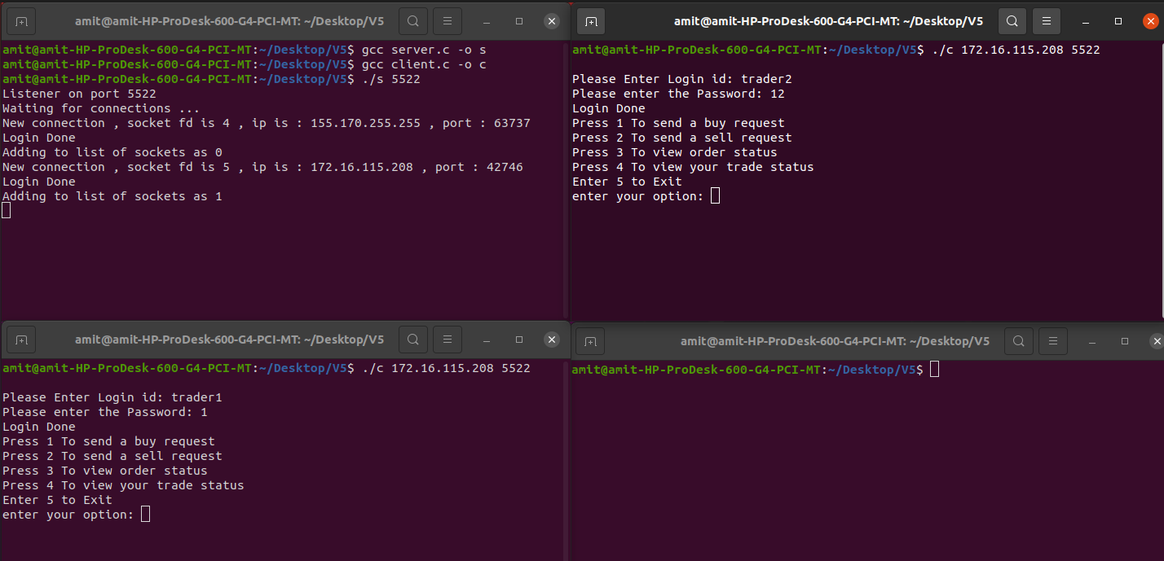

**4.1.4** Here Server is listening on port number 5522 and when the third client starts, the IP address 172.16.115.208 and port number 5522 of the server is given to it. Third Client sends request to create connection on that IP address on a given port.Once the server receives the request from the client, it accepts the connection and assigns that client a new port number 42748, with which the client will communicate for further tasks.

